Honoring Those Who Gave All

A MEMORIAL DAY BAND CONCERT

*Heroes of the American Revolution*

Jerry Brubaker

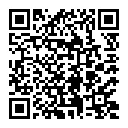

*The Blue and the Gray*

Clare Grundman



*Echoes from the Battlefield*

Darren Jenkins



*The Honored Dead*

John Philip Sousa



**Intermission**

*Hymn to the Fallen*

John Williams



*Forgotten Heroes*

Jeremy Bell



*Reflections from the Wall*

David Shaffer



*Encomium for the Courageous*

Nolan E. Schmit



*Tribute for Band*

Major General Daniel Butterfield, U.S. Army

Arr. Michael Miller

